|  |
| --- |
| Proposal |

|  |
| --- |
| BIKE DEALERSHIP SYSTEM |

|  |  |
| --- | --- |
| FA21-BCS-112 Dawood Nadeem |  |

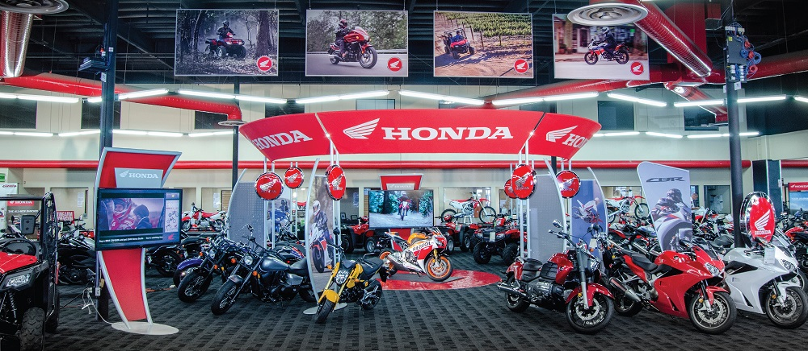

Introduction

The purpose of this project is to design and develop a bike dealership management system that will help bike dealers to manage their inventory, sales, and customer information efficiently. The system will be designed to store and manage data related to bikes, customers, suppliers, and sales. The system will be developed using a database management system, and the data will be stored in a relational database. The system will be easy to use, and it will provide a user-friendly interface for dealers to manage their shop operations.

Objectives

The objectives of the bike dealer shop management system are:

* To provide an efficient way for bike dealers to manage their inventory, sales, and customer information.
* To reduce manual work and increase efficiency in shop operations.
* To provide accurate and timely information for decision-making.
* To improve customer satisfaction by providing better services.

Tools and Technologies

* Relational Database Management System (RDBMS): MySQL will be used to implement the database.
* Programming Languages: Java and Javafx will be used to develop the user interface.
* Integrated Development Environment (IDE): IntelliJ Idea, SceneBuilder and MS SQL will be used.
* Code Hosting Platform: Github

Scope

The scope of the Bike Dealership Management System project is to design and develop a comprehensive system that will allow bike dealers to manage their inventory, sales, and customer information. The system will provide features such as bike inventory management, sales management, customer management, supplier management, user management, security, and scalability. It will also offer valuable reports to support decision-making.

The system will be developed using a database management system, MySQL, as the backend technology, and Java, JavaFX and Scene builder as the frontend technologies. The system will have a user-friendly interface and be designed to be scalable, secure, and efficient. This system will enable bike dealers to streamline their operations, reducing manual work and increasing efficiency. It will also help dealers provide better services and improve customer satisfaction.

Features:

The bike dealer shop management system will have the following features:

* Bike Inventory Management: The system will allow bike dealers to manage their bike inventory, including adding new bikes, updating existing bikes, and deleting bikes. The system will also provide information about the bikes, including the make, model, color, and price.
* Sales Management: The system will allow bike dealers to manage their sales, including adding new sales, updating existing sales, and deleting sales. The system will also provide information about the sales, including the date of the sale, the customer’s name, and the bike sold.
* Customer Management: The system will allow bike dealers to manage their customer information, including adding new customers, updating existing customers, and deleting customers. The system will also provide information about the customers, including their name, address, phone number, and email address.
* Supplier Management: The system will allow bike dealers to manage their supplier information, including adding new suppliers, updating existing suppliers, and deleting suppliers. The system will also provide information about the suppliers, including their name, address, phone number, and email address.
* Reports: The system will provide various reports, including sales reports, inventory reports, customer reports, and supplier reports. The reports will provide valuable information to bike dealers for decision-making.

Conclusion

In conclusion, the bike dealership management system will be an efficient way for bike dealers to manage their inventory, sales, and customer information. The system will be designed to store and manage data related to bikes, customers, suppliers, and sales. The system will be developed using a database management system, and the data will be stored in a relational database. The system will be easy to use and provide a user-friendly interface for dealers to manage their shop operations.